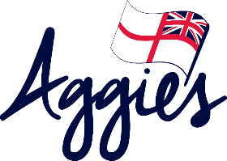
Aggie Weston’s is dedicated to those serving in the Royal Navy, Royal Marines, Royal Fleet Auxiliary and their families. Aggie’s provides support to personnel and their families through the provision of Pastoral Workers and practical projects. Pastoral Workers are located across the UK in base ports, air stations, RM units, training schools, Whale Island and in service family accommodation areas. They are there to listen to you, support you, provide comfort and where appropriate signpost you or your family to other organisations. In addition to this our pastoral workers provide a range of practical support that includes staffing the coffee bars and havens with the NCS, provision of regular and ad-hoc events for families and helping with Storybook Waves recordings and running Storybook Waves Book Clubs within service family accommodation areas.
For more information on how to access Aggie’s services visit www.aggies.org.uk

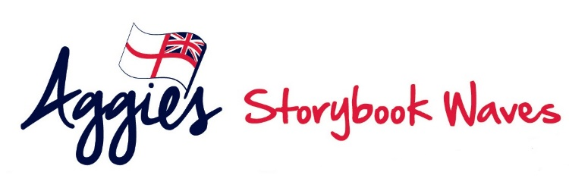
Storybook Waves is a practical project provided by Aggie Weston’s to enable personnel serving in the Royal Navy, Royal Marines and Royal Fleet Auxiliary to record a bedtime story for their children to listen to whilst they are separated. Recording is simple and accessed via Pastoral Workers who work across the UK within the NCS. A recording will take about twenty minutes and after the session, volunteer editors add sound effects to your story before it is added to the special pack that is posted to your family.
Deploying ships and units can request a small kit to take away with them by emailing storybookwaves@aggies.org.uk.
For more information on Aggie’s Storybook Waves please visit www.aggies.org.uk/storybookwaves

